**Sequence And Series**

**Sequence**

* A **sequence** is an **ordered list of numbers** **following a specific pattern** or rule.
* **Example**: 2,4,6,8
* Each number in a sequence is called a **term**.

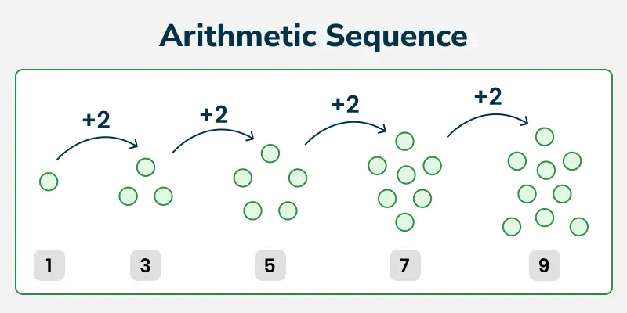

An **arithmetic sequence** (or arithmetic progression) is a sequence of numbers **in which the difference between consecutive terms is constant**. This difference is called the [**common difference**](https://www.geeksforgeeks.org/what-is-the-common-difference-of-an-arithmetic-progression/) (denoted as d).

**For example:**

👉 2, 5, 8, 11, 14, . . . (first term = 2 and common difference = 3)

A **geometric sequence** (or geometric progression) is a sequence of numbers in which the ratio between consecutive terms is constant. This ratio is known as the **common ratio** (denoted as r)

**For example:**

👉 3, 6, 12, 24, 48, . . . (first term = 3 and common ratio = 2)

**Series:**

* A **series** is the sum of the terms of a sequence.
* Series as Terms of a Sequence connected by **positive (+)** or **negative (-)** signs.
* **Example**: 2+4+6+8

**Infinite vs. Finite Sequences and Series**

**Finite Sequence:**

* A sequence with a **limited** number of terms.
* **Example:** 1,2,3,4,5

**Infinite Sequence:**

* A sequence with an **unlimited** number of terms.
* Example: 1,2,3,4,5, …

**General Term or nth Term**

* The **general term** of a sequence represents any term **(Tn​)** in the sequence using a formula.
* It is **used to find the value of a term at a specific position**.

**Example 1 (Arithmetic Sequence):**

* Sequence: 2,4,6,8
* General term: **an=2n**

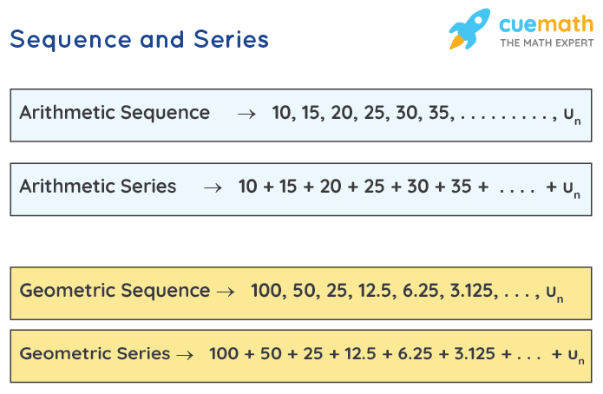

**👉 General term or nth term of Arithmetic Series**

**an = a + (n−1)d**

Where,

* **a** is the first term
* **d** is the common difference
* **n** is the number of terms
* **an** is the nth term

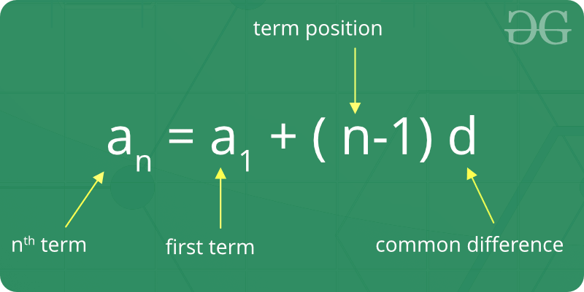

**Arithmetic Series for 3 Numbers:**

**a−d,a,a+d**

**Arithmetic Series for 4 Numbers:**

**a−3d​,a−d​,a+d​,a+3d​**

**Arithmetic Series for 5 Numbers:**

**a−2d,a−d,a,a+d,a+2d**

**👉 Sum of First n Terms**

**Sn = n/2 [2a + (n−1)d]**

Where,

* **a** is the first term
* **d** is the common difference
* **n** is the number of terms.

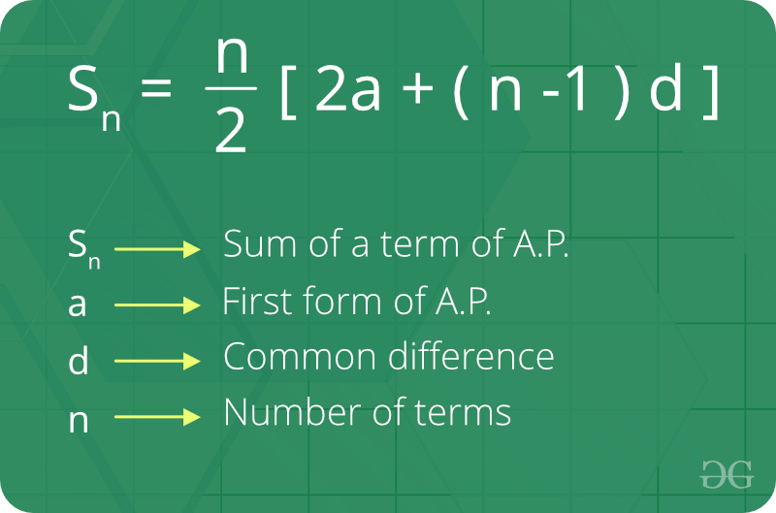

If we know the **last term** of an **arithmetic sequence,** the **formula** to find the **sum** of the first **n** terms **(Sn)** is:

**Sn​= n / 2 ​⋅ (First Term+Last Term)**

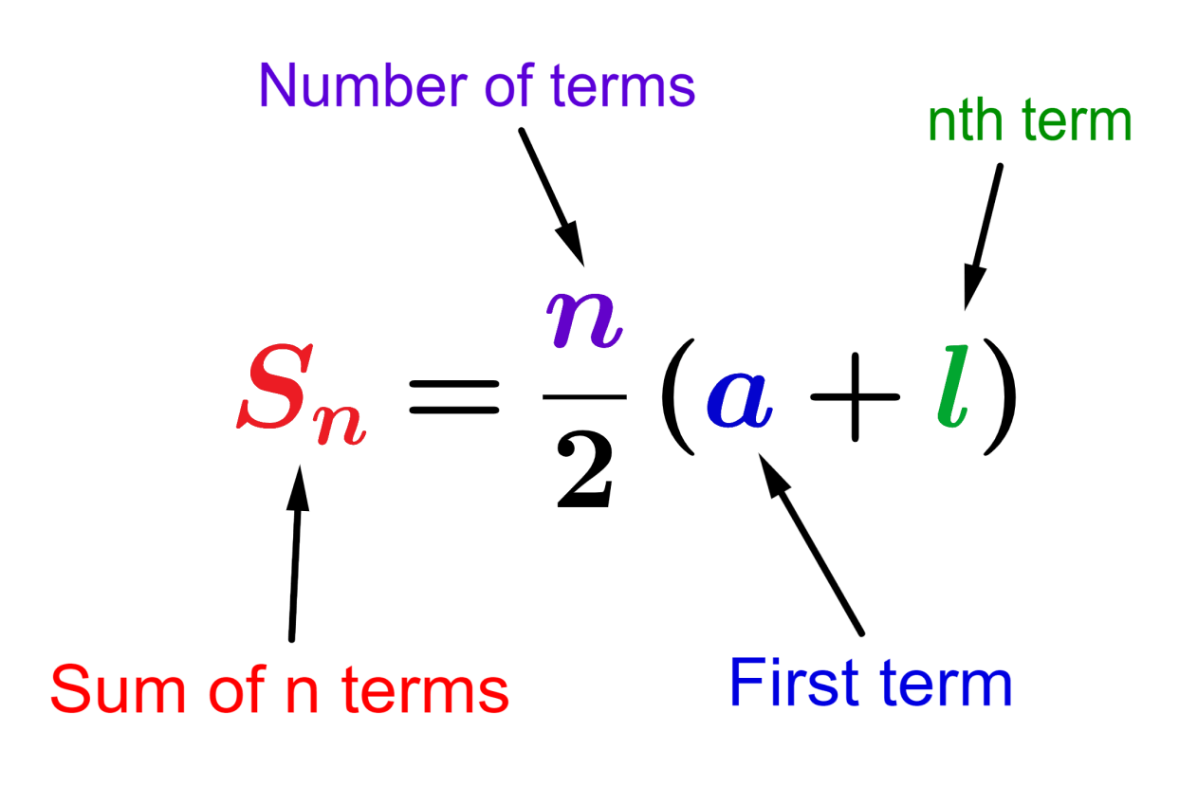

**Quadratic Equation**

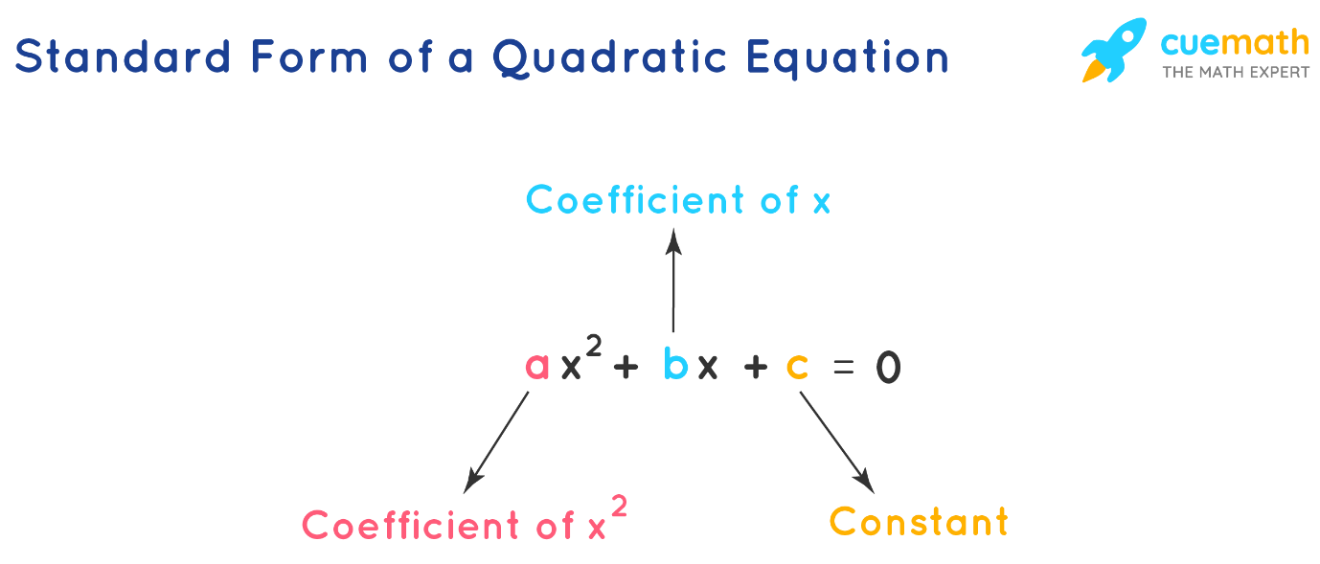

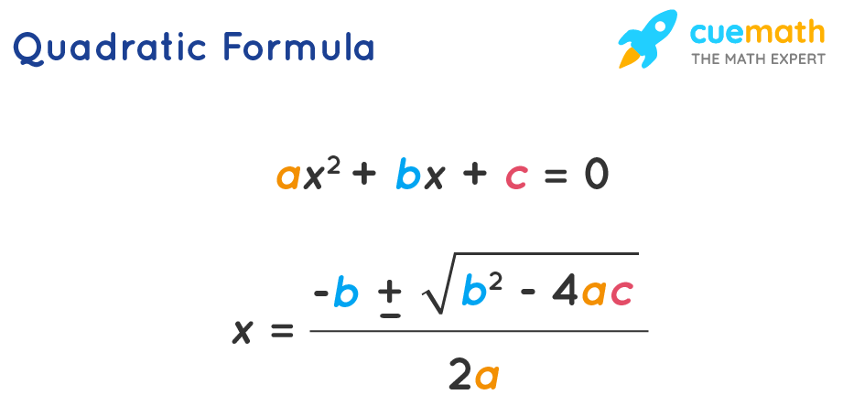

**Arithmetic Mean**

The **Arithmetic Mean (AM)** is the average of two terms in an Arithmetic Progression (AP).

If three numbers **a,A,b** are in AP, the middle term A is the **Arithmetic Mean** of a and b, and it is given by:

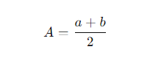

**a2​=a+d**

**a3=a+2d**

**a4​=a+3d**

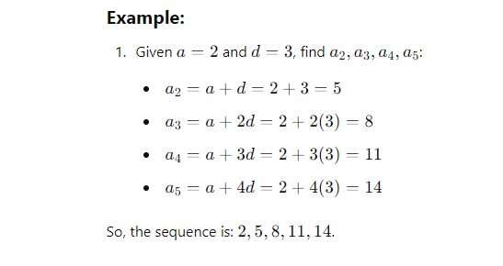

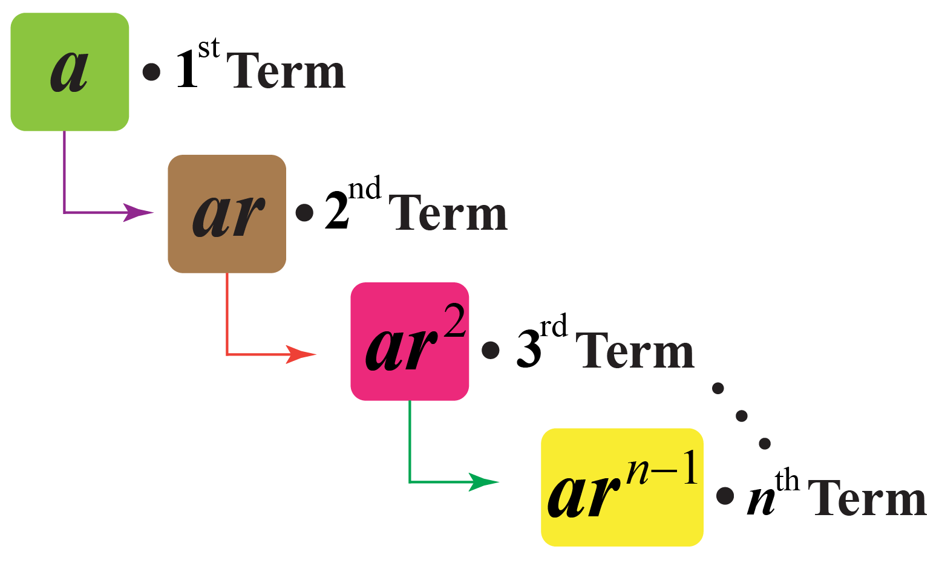

**Geometric Progression (GP)**

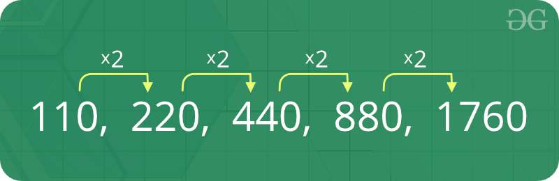

**General Form of Geometric Progression**

The nth term of the Geometric series is denoted by**an**

**a1 = a**  
**a2 = a*r**   
**a3 = a*r2**  
**a4 = a*r3**  
**an = a*rn-1**

**Geometric Progression Formula**

|  |  |  |
| --- | --- | --- |
| **General Form** | a,ar,ar2,ar3,… | ***a* is the first term**, and ***r* is the common ratio.** |

|  |  |  |
| --- | --- | --- |
| **👉 nth Term of a GP** | **Tn = arn-1** | **Tnis the nth term**, *a* is the first term, and r is the common ratio. |

|  |  |
| --- | --- |
| **Sum of First n Terms (r > 1)** | **Sn = a[(rn – 1)/(r – 1)]** |
| **Sum of First n Terms (r < 1)** | **Sn = a[(1 – rn)/(1 – r)]** |

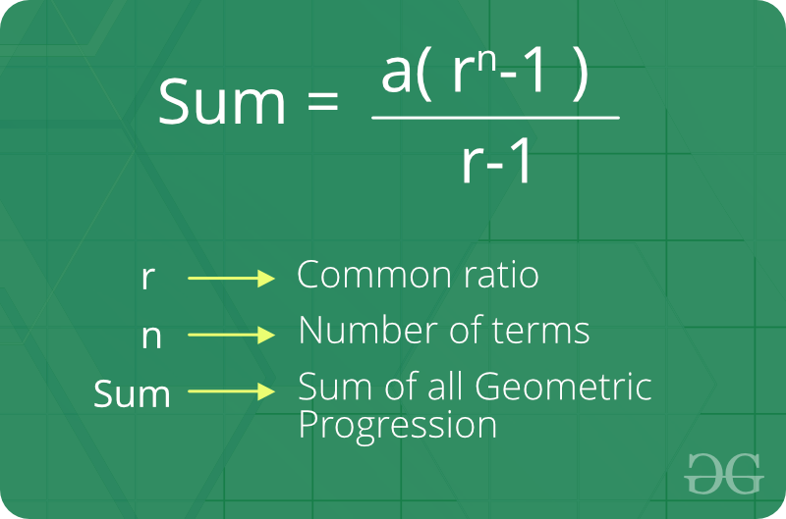

**👉 Infinite Terms of a G.P**

The formula **a/1-r = Sn** works when n is equal to infinity.

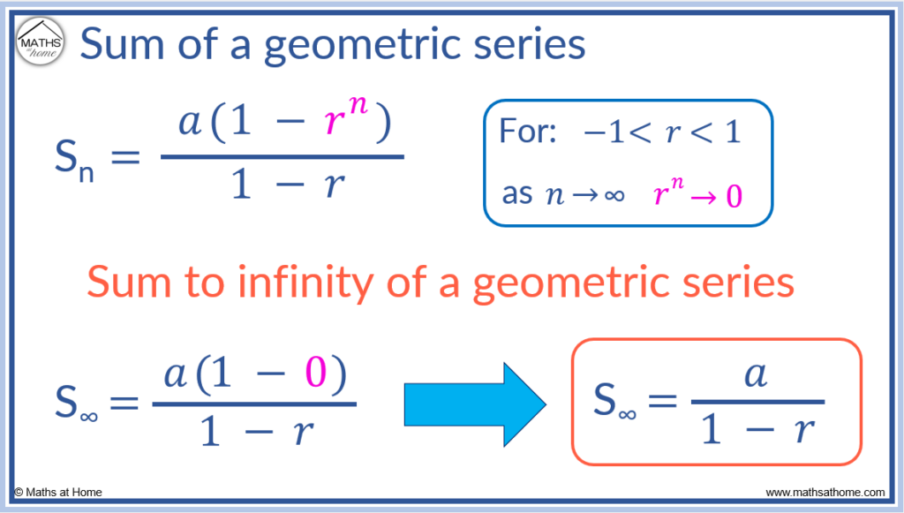

**Geometric Mean**

**Geometric Mean of A and B**

**G =√ab**